ACLRS — Laboratory Management Portal PHP Evidence
PHP-only implementation evidence. Source code comments have been removed.
PHP 1 — Dashboard
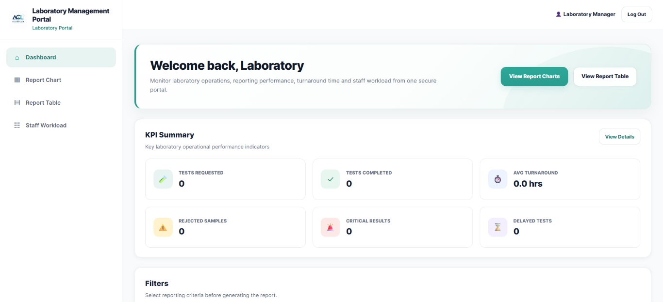
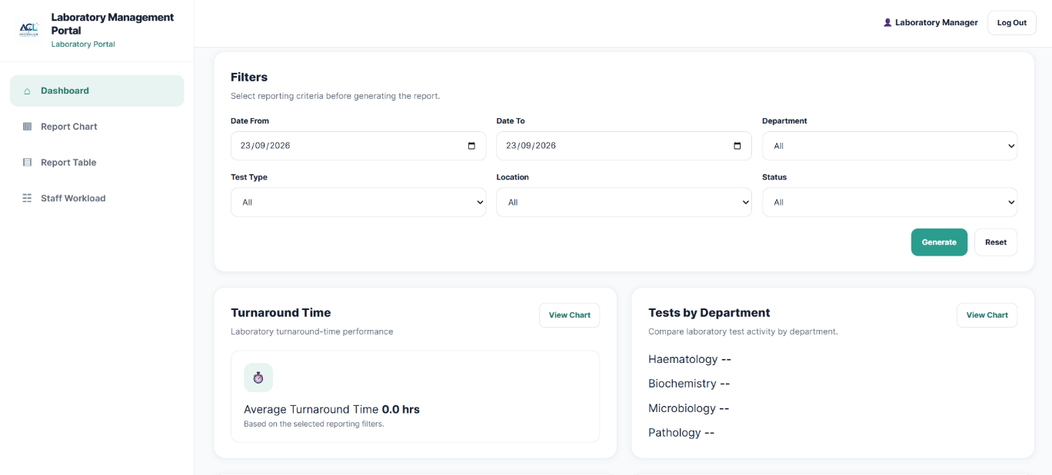
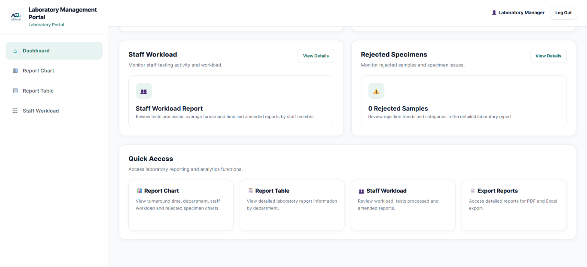
Source file: pages/staff/manager/dashboard.php
PHP controller: pages/staff/manager/controllers/AnalyticsController.php
Data source: pages/staff/manager/laboratory-report-data.php
Purpose: Provides laboratory managers with an overview of laboratory operational performance, including KPI summaries, reporting filters, turnaround time, test volumes, rejected specimens, critical results, delayed tests and staff workload information.
<?php
require_once __DIR__ . '/_manager_auth.php';

if (session_status() === PHP_SESSION_NONE) {
session_start();
}

$analyticsController = __DIR__ . '/controllers/AnalyticsController.php';
if (file_exists($analyticsController)) {
require_once $analyticsController;
}

$managerName = $managerName ?? ($_SESSION['manager_name'] ?? 'Name of Manager');
$firstName = $firstName ?? (explode(' ', trim($managerName))[0] ?: 'Manager');

$kpiSummary = $kpiSummary ?? [
'tests_requested' => 0,
'tests_completed' => 0,
'average_tat' => '0.0 hrs',
'rejected_samples' => 0,
'critical_results' => 0,
'delayed_tests' => 0
];

$filters = $filters ?? [
'date_from' => $_GET['date_from'] ?? '',
'date_to' => $_GET['date_to'] ?? '',
'department' => $_GET['department'] ?? 'All',
'test_type' => $_GET['test_type'] ?? 'All',
'location' => $_GET['location'] ?? 'All',
'status' => $_GET['status'] ?? 'All'
];

$departments = $departments ?? ['All', 'Haematology', 'Biochemistry', 'Microbiology', 'Pathology'];
$testTypes = $testTypes ?? ['All', 'Blood Test', 'Urine Test', 'Biochemistry', 'Microbiology', 'Pathology'];
$locations = $locations ?? ['All', 'Melbourne', 'Sydney', 'Brisbane', 'Other'];
$statuses = $statuses ?? ['All', 'Requested', 'Completed', 'Delayed', 'Rejected', 'Critical'];

?>

<?php
require_once __DIR__ . '/../laboratory-report-data.php';

$kpiSummary = $reportKpi;
$analyticsError = $reportError;
$filters = $reportFilters;

$managerName = $_SESSION['manager_name'] ?? $_SESSION['name'] ?? 'Laboratory Manager';
$firstName = explode(' ', trim($managerName))[0] ?: 'Manager';
?>

PHP 2 — Report Chart
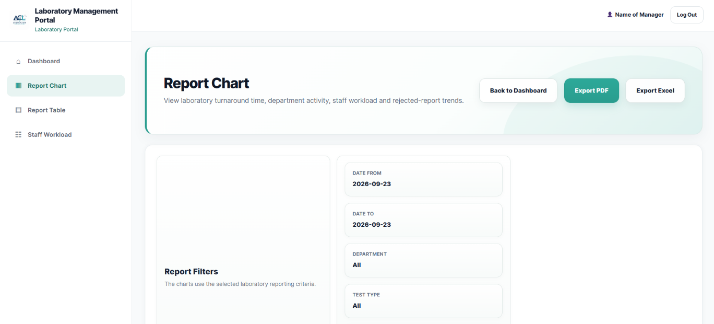
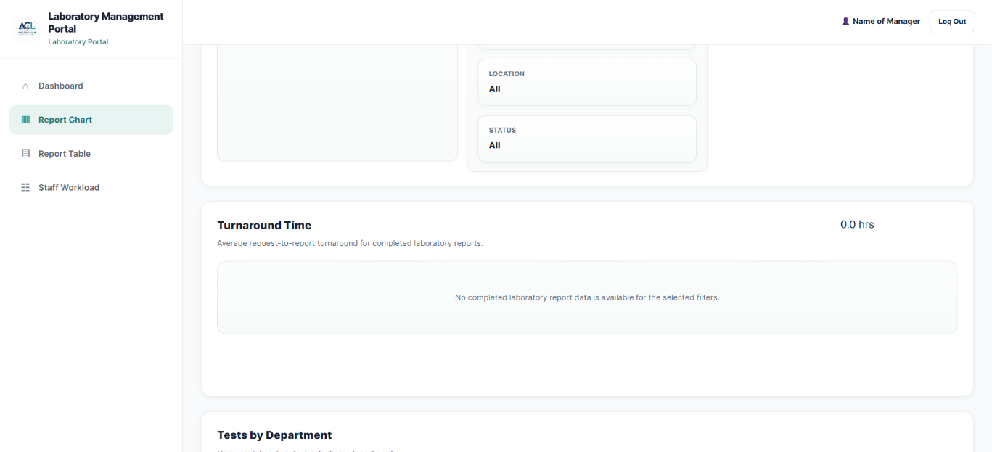
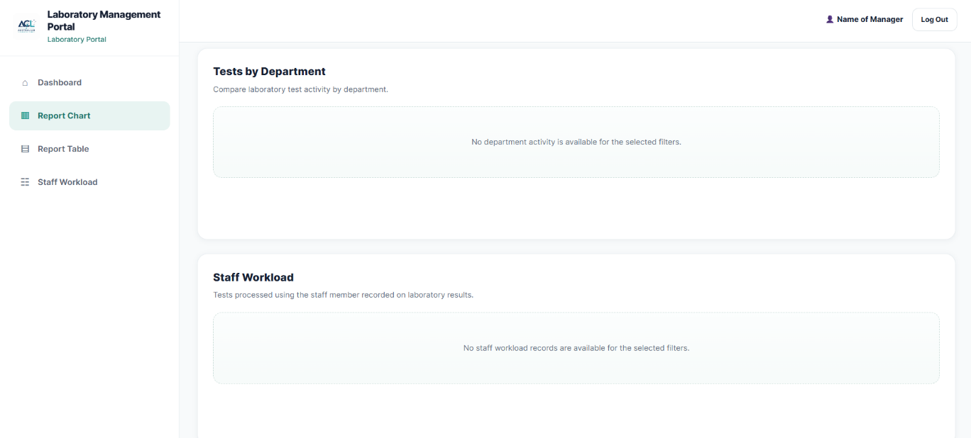
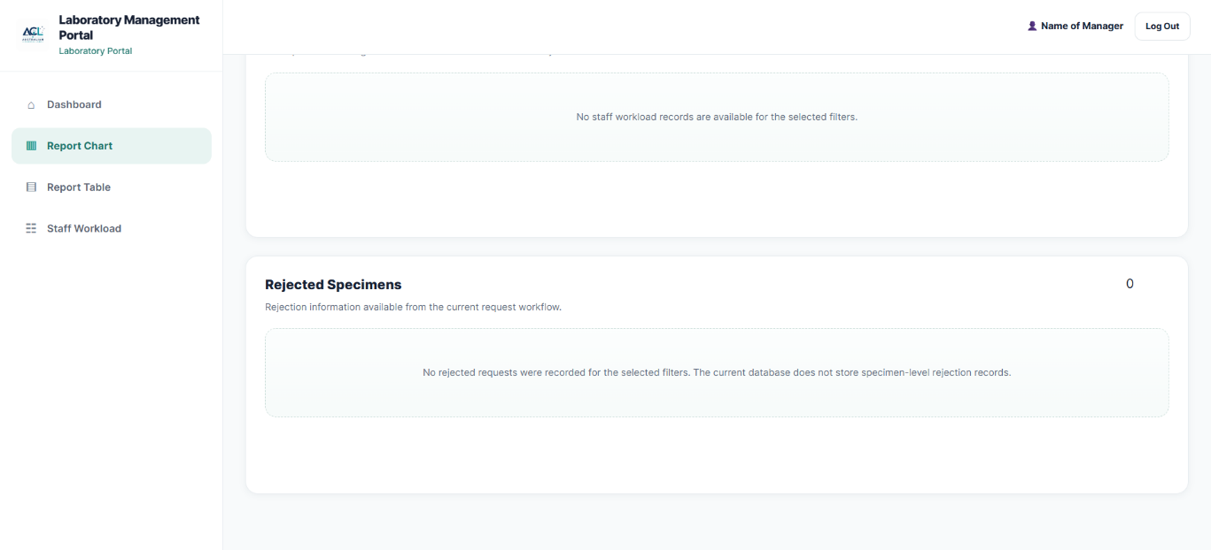
Source file: pages/staff/manager/report-chart.php
Data source: pages/staff/manager/laboratory-report-data.php
Purpose: Provides laboratory managers with visual reports of laboratory operational performance. The interface applies selected reporting filters and presents laboratory data through charts, including turnaround time, departmental test activity, staff workload and rejected specimen information.
<?php
require_once __DIR__ . '/_manager_auth.php';

require_once __DIR__ . '/controllers/AnalyticsController.php';
require_once __DIR__ . '/laboratory-report-data.php';

$reportError = $reportError ?? '';
$analyticsError = $analyticsError ?? '';

if ($analyticsError !== '') {
$reportError = $reportError !== ''
? $reportError . ' ' . $analyticsError
: $analyticsError;
}

$managerName = $_SESSION['manager_name'] ?? 'Name of Manager';
$firstName = explode(' ', trim($managerName))[0] ?: 'Manager';

?>

PHP 3 — Report Table
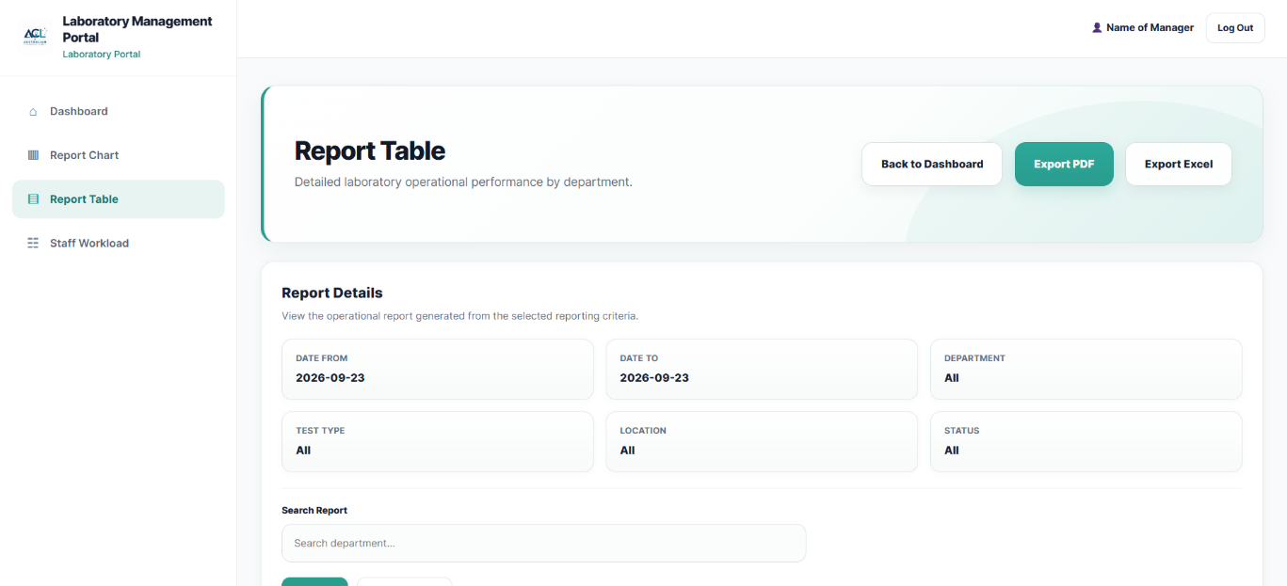
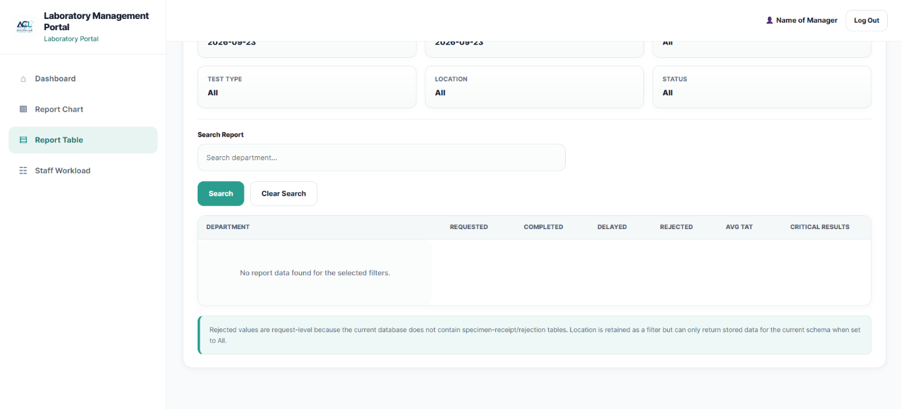
Source file: pages/staff/manager/report-table.php
Data source: pages/staff/manager/laboratory-report-data.php
Purpose: Provides laboratory managers with detailed laboratory reporting information in a tabular format. The PHP implementation applies reporting and search criteria and presents filtered laboratory test information for operational analysis and report export.
<?php
require_once __DIR__ . '/_manager_auth.php';

if (session_status() === PHP_SESSION_NONE) {
session_start();
}

require_once __DIR__ . '/laboratory-report-data.php';

$search = trim($_GET['search'] ?? '');

$managerName = $_SESSION['manager_name'] ?? $_SESSION['name'] ?? 'Name of Manager';
$firstName = explode(' ', trim($managerName))[0] ?: 'Manager';

$tableRows = [];

foreach ($departmentRows as $row) {
$tableRows[] = [
'department' => $row['department'] ?? 'Uncategorised',
'requested' => (int)($row['requested'] ?? 0),
'completed' => (int)($row['completed'] ?? 0),
'delayed' => (int)($row['delayed'] ?? 0),
'rejected' => (int)($row['rejected'] ?? 0),
'avg_tat' => null,
'critical_results' => (int)($row['critical'] ?? 0)
];
}

$departmentTat = [];
foreach ($detailRows as $row) {
$departmentName = trim((string)($row['department'] ?? '')) ?: 'Unassigned';
$start = strtotime((string)($row['requested_at'] ?? ''));
$endText = $row['work_completed_at'] ?: $row['report_date'];
$end = $endText ? strtotime((string)$endText) : false;

if ($start !== false && $end !== false && $end >= $start) {
$departmentTat[$departmentName][] = ($end - $start) / 3600;
}
}

foreach ($tableRows as &$row) {
$name = $row['department'];
if (!empty($departmentTat[$name])) {
$row['avg_tat'] = array_sum($departmentTat[$name]) / count($departmentTat[$name]);
}
}
unset($row);

if ($search !== '') {
$tableRows = array_values(array_filter($tableRows, function (array $row) use ($search): bool {
return stripos($row['department'], $search) !== false;
}));
}

$queryBase = [
'date_from' => $dateFrom,
'date_to' => $dateTo,
'department' => $department,
'test_type' => $testType,
'location' => $location,
'status' => $status
];

$pdfUrl = 'export-report-pdf.php?' . http_build_query($queryBase);
$excelUrl = 'export-report-excel.php?' . http_build_query($queryBase);
?>

PHP 4 — Staff Workload
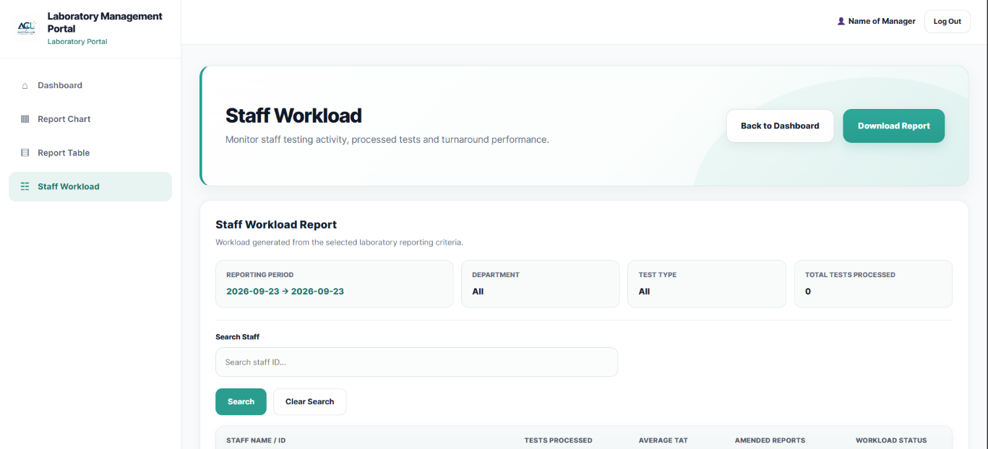
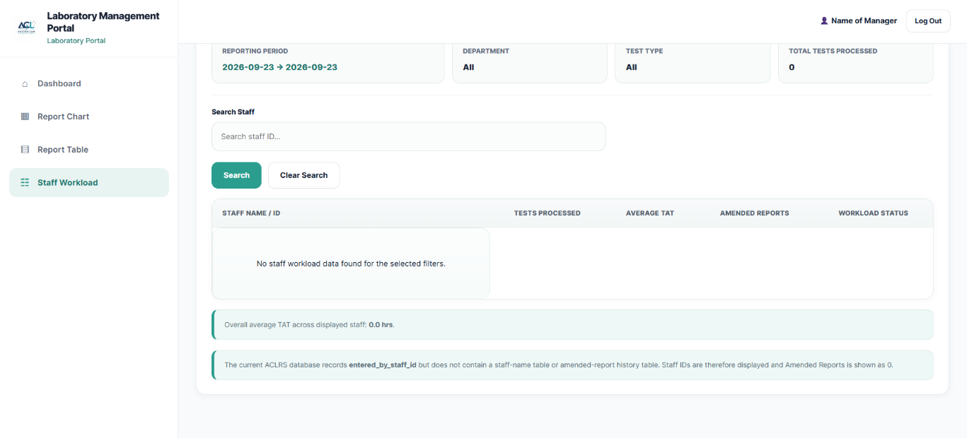
Source file: pages/staff/manager/staff-workload.php
Data source: pages/staff/manager/laboratory-report-data.php
Purpose: Provides laboratory managers with staff workload and performance information for the selected reporting period. The PHP implementation retrieves and filters staff workload data, including tests processed, turnaround-time information and reporting activity, and supports workload report export.
<?php
require_once __DIR__ . '/_manager_auth.php';

if (session_status() === PHP_SESSION_NONE) {
session_start();
}

require_once __DIR__ . '/laboratory-report-data.php';

$search = trim((string)($_GET['search'] ?? ''));

$managerName = $_SESSION['manager_name'] ?? $_SESSION['name'] ?? 'Name of Manager';
$firstName = explode(' ', trim($managerName))[0] ?: 'Manager';

$workloadRows = is_array($staffRows ?? null) ? $staffRows : [];

if (in_array(strtolower((string)$status), ['requested', 'rejected'], true)) {
$workloadRows = [];
}

if ($search !== '') {
$workloadRows = array_values(array_filter(
$workloadRows,
static function (array $row) use ($search): bool {
return stripos((string)($row['staff_id'] ?? ''), $search) !== false
|| stripos((string)($row['staff_name'] ?? ''), $search) !== false
|| stripos((string)($row['department'] ?? ''), $search) !== false;
}
));
}

$queryBase = [
'date_from' => $dateFrom,
'date_to' => $dateTo,
'department' => $department,
'test_type' => $testType,
'location' => $location,
'status' => $status
];

$workloadExportUrl = 'export-workload.php?' .
http_build_query($queryBase);

$clearSearchUrl = 'staff-workload.php?' .
http_build_query($queryBase);

$totalTestsProcessed = 0;
$totalAverageTat = [];

foreach ($workloadRows as $row) {
$totalTestsProcessed += (int)($row['tests_processed'] ?? 0);

if (isset($row['average_tat']) && is_numeric($row['average_tat'])) {
$totalAverageTat[] = (float)$row['average_tat'];
}
}

$overallAverageTat = !empty($totalAverageTat)
? array_sum($totalAverageTat) / count($totalAverageTat)
: 0;
?>

Shared Reporting Data Processing
Data source: pages/staff/manager/laboratory-report-data.php

<?php
require_once __DIR__ . '/_manager_auth.php';

if (session_status() === PHP_SESSION_NONE) {
session_start();
}

require_once __DIR__ . '/../../../config/database.php';

$dateFrom = trim((string)($_GET['date_from'] ?? ''));
$dateTo = trim((string)($_GET['date_to'] ?? ''));
$department = trim((string)($_GET['department'] ?? 'All'));
$testType = trim((string)($_GET['test_type'] ?? 'All'));
$location = trim((string)($_GET['location'] ?? 'All'));
$status = trim((string)($_GET['status'] ?? 'All'));

if ($dateFrom === '') $dateFrom = date('Y-m-d');
if ($dateTo === '') $dateTo = $dateFrom;
if ($dateFrom > $dateTo) [$dateFrom, $dateTo] = [$dateTo, $dateFrom];

$departments = ['All'];
$testTypes = ['All'];
$locations = ['All'];
$statuses = ['All', 'Requested', 'Completed', 'Delayed', 'Rejected', 'Critical'];

$reportError = '';
$reportKpi = [
'tests_requested' => 0,
'tests_completed' => 0,
'average_tat' => '0.0 hrs',
'rejected_samples' => 0,
'critical_results' => 0,
'delayed_tests' => 0
];

$departmentRows = [];
$turnaroundRows = [];
$staffRows = [];
$rejectedRows = [];
$detailRows = [];

try {
foreach ($pdo->query("SELECT DISTINCT department FROM worklist WHERE department IS NOT NULL AND TRIM(department) <> '' ORDER BY department")->fetchAll(PDO::FETCH_COLUMN) as $v) {
$departments[] = $v;
}

foreach ($pdo->query("SELECT test_name FROM test_catalogue WHERE active_status = 1 ORDER BY test_name")->fetchAll(PDO::FETCH_COLUMN) as $v) {
$testTypes[] = $v;
}

foreach ($pdo->query("SELECT DISTINCT collection_location FROM specimen_collection WHERE collection_location IS NOT NULL AND TRIM(collection_location) <> '' ORDER BY collection_location")->fetchAll(PDO::FETCH_COLUMN) as $v) {
$locations[] = $v;
}

if (!in_array($department, $departments, true)) $department = 'All';
if (!in_array($testType, $testTypes, true)) $testType = 'All';
if (!in_array($location, $locations, true)) $location = 'All';
if (!in_array($status, $statuses, true)) $status = 'All';

$where = [
'rq.requested_at >= :date_from',
'rq.requested_at < DATE_ADD(:date_to, INTERVAL 1 DAY)'
];
$params = [
':date_from' => $dateFrom . ' 00:00:00',
':date_to' => $dateTo . ' 00:00:00'
];

if ($testType !== 'All') {
$where[] = 'tc.test_name = :test_type';
$params[':test_type'] = $testType;
}

if ($department !== 'All') {
$where[] = "EXISTS (SELECT 1 FROM worklist wf WHERE wf.request_item_id = ri.request_item_id AND wf.department = :department)";
$params[':department'] = $department;
}

if ($location !== 'All') {
$where[] = "EXISTS (
SELECT 1
FROM specimens sl
INNER JOIN specimen_collection scl ON scl.specimen_id = sl.specimen_id
WHERE sl.request_item_id = ri.request_item_id
AND scl.collection_location = :location
)";
$params[':location'] = $location;
}

$whereSql = implode("\n AND ", $where);

$sql = "
SELECT
ri.request_item_id,
ri.request_id,
ri.item_status,
rq.requested_at,
rq.request_status,
rq.priority,
tc.test_id,
tc.test_code,
tc.test_name,
tc.specimen_type,
tc.expected_completion_minutes,

COALESCE(
(SELECT w.department FROM worklist w WHERE w.request_item_id = ri.request_item_id ORDER BY w.worklist_id DESC LIMIT 1),
'Unassigned'
) AS department,

(SELECT w.assigned_staff_id FROM worklist w WHERE w.request_item_id = ri.request_item_id ORDER BY w.worklist_id DESC LIMIT 1) AS assigned_staff_id,

(SELECT CONCAT(s.first_name, ' ', s.last_name)
FROM worklist w
INNER JOIN staff s ON s.staff_id = w.assigned_staff_id
WHERE w.request_item_id = ri.request_item_id
ORDER BY w.worklist_id DESC LIMIT 1) AS staff_name,

(SELECT MAX(w.completed_at) FROM worklist w WHERE w.request_item_id = ri.request_item_id) AS work_completed_at,
(SELECT MAX(lr.report_date) FROM lab_reports lr WHERE lr.request_id = ri.request_id AND lr.report_status IN ('final','corrected','amended')) AS report_date,

(SELECT MAX(sc.collection_location)
FROM specimens sp
INNER JOIN specimen_collection sc ON sc.specimen_id = sp.specimen_id
WHERE sp.request_item_id = ri.request_item_id) AS collection_location,

(SELECT COUNT(DISTINCT sr.specimen_id)
FROM specimens sp
INNER JOIN specimen_receipts sr ON sr.specimen_id = sp.specimen_id
WHERE sp.request_item_id = ri.request_item_id
AND sr.acceptance_status = 'rejected') AS rejected_specimens,

(SELECT COUNT(*)
FROM test_results tr
INNER JOIN test_parameters tp ON tp.parameter_id = tr.parameter_id
WHERE tr.request_item_id = ri.request_item_id
AND (
tr.result_flag IN ('critical_low','critical_high')
OR (tr.result_numeric IS NOT NULL AND tp.critical_low IS NOT NULL AND tr.result_numeric < tp.critical_low)
OR (tr.result_numeric IS NOT NULL AND tp.critical_high IS NOT NULL AND tr.result_numeric > tp.critical_high)
)) AS critical_results

FROM test_request_items ri
INNER JOIN test_requests rq ON rq.request_id = ri.request_id
INNER JOIN test_catalogue tc ON tc.test_id = ri.test_id
WHERE $whereSql
ORDER BY rq.requested_at DESC, ri.request_item_id DESC
";

$stmt = $pdo->prepare($sql);
$stmt->execute($params);
$allRows = $stmt->fetchAll(PDO::FETCH_ASSOC);

$now = time();
foreach ($allRows as &$row) {
$start = strtotime((string)$row['requested_at']);
$completionText = $row['work_completed_at'] ?: $row['report_date'];
$end = $completionText ? strtotime((string)$completionText) : false;

$completed = strtolower((string)$row['item_status']) === 'completed' || $end !== false;
$tatHours = null;
if ($start !== false && $end !== false && $end >= $start) {
$tatHours = ($end - $start) / 3600;
}

$expectedMinutes = (int)($row['expected_completion_minutes'] ?? 0);
$elapsedMinutes = $start !== false ? ((($end !== false ? $end : $now) - $start) / 60) : 0;
$delayed = $expectedMinutes > 0 && $elapsedMinutes > $expectedMinutes;
$rejected = (int)$row['rejected_specimens'] > 0;
$critical = (int)$row['critical_results'] > 0;
$requested = !$completed && !$rejected;

$row['_completed'] = $completed;
$row['_requested'] = $requested;
$row['_delayed'] = $delayed;
$row['_rejected'] = $rejected;
$row['_critical'] = $critical;
$row['_tat_hours'] = $tatHours;
$row['_target'] = $expectedMinutes > 0 ? $expectedMinutes . ' min' : 'Not configured';
}
unset($row);

$detailRows = array_values(array_filter($allRows, static function (array $row) use ($status): bool {
switch (strtolower($status)) {
case 'requested': return !empty($row['_requested']);
case 'completed': return !empty($row['_completed']);
case 'delayed': return !empty($row['_delayed']);
case 'rejected': return !empty($row['_rejected']);
case 'critical': return !empty($row['_critical']);
default: return true;
}
}));

$tatValues = [];
$testBuckets = [];
$deptBuckets = [];
$staffBuckets = [];

foreach ($detailRows as $row) {
$reportKpi['tests_requested']++;
if ($row['_completed']) $reportKpi['tests_completed']++;
if ($row['_delayed']) $reportKpi['delayed_tests']++;
$reportKpi['rejected_samples'] += (int)$row['rejected_specimens'];
$reportKpi['critical_results'] += (int)$row['critical_results'];
if ($row['_tat_hours'] !== null) $tatValues[] = (float)$row['_tat_hours'];

$dept = trim((string)$row['department']) ?: 'Unassigned';
if (!isset($deptBuckets[$dept])) {
$deptBuckets[$dept] = ['department'=>$dept,'requested'=>0,'completed'=>0,'delayed'=>0,'rejected'=>0,'critical'=>0];
}
$deptBuckets[$dept]['requested']++;
if ($row['_completed']) $deptBuckets[$dept]['completed']++;
if ($row['_delayed']) $deptBuckets[$dept]['delayed']++;
$deptBuckets[$dept]['rejected'] += (int)$row['rejected_specimens'];
$deptBuckets[$dept]['critical'] += (int)$row['critical_results'];

$testId = (int)$row['test_id'];
if (!isset($testBuckets[$testId])) {
$testBuckets[$testId] = [
'test_name'=>(string)$row['test_name'],
'category'=>$dept,
'target'=>(string)$row['_target'],
'tat'=>[]
];
}
if ($row['_tat_hours'] !== null) $testBuckets[$testId]['tat'][] = (float)$row['_tat_hours'];

$staffId = $row['assigned_staff_id'];
if ($staffId !== null && $row['_completed']) {
$staffKey = (string)$staffId;
if (!isset($staffBuckets[$staffKey])) {
$staffBuckets[$staffKey] = [
'staff_id'=>$staffKey,
'staff_name'=>(string)($row['staff_name'] ?: ('Staff ' . $staffKey)),
'department'=>$dept,
'tests_processed'=>0,
'tat'=>[]
];
}
$staffBuckets[$staffKey]['tests_processed']++;
if ($row['_tat_hours'] !== null) $staffBuckets[$staffKey]['tat'][] = (float)$row['_tat_hours'];
}
}

if ($tatValues) {
$reportKpi['average_tat'] = number_format(array_sum($tatValues) / count($tatValues), 1) . ' hrs';
}

$departmentRows = array_values($deptBuckets);
usort($departmentRows, static fn($a,$b) => $b['requested'] <=> $a['requested']);

foreach ($testBuckets as $b) {
if (!$b['tat']) continue;
$turnaroundRows[] = [
'test_name'=>$b['test_name'],
'category'=>$b['category'],
'average_tat'=>array_sum($b['tat']) / count($b['tat']),
'target'=>$b['target']
];
}
usort($turnaroundRows, static fn($a,$b) => $b['average_tat'] <=> $a['average_tat']);

foreach ($staffBuckets as $b) {
$staffRows[] = [
'staff_id'=>$b['staff_id'],
'staff_name'=>$b['staff_name'],
'department'=>$b['department'],
'tests_processed'=>$b['tests_processed'],
'average_tat'=>$b['tat'] ? array_sum($b['tat']) / count($b['tat']) : 0
];
}
usort($staffRows, static fn($a,$b) => $b['tests_processed'] <=> $a['tests_processed']);

$rejWhere = [
'rq.requested_at >= :rfrom',
'rq.requested_at < DATE_ADD(:rto, INTERVAL 1 DAY)',
"sr.acceptance_status = 'rejected'"
];
$rejParams = [':rfrom'=>$dateFrom.' 00:00:00', ':rto'=>$dateTo.' 00:00:00'];
if ($testType !== 'All') { $rejWhere[]='tc.test_name = :rtest'; $rejParams[':rtest']=$testType; }
if ($location !== 'All') { $rejWhere[]='sc.collection_location = :rlocation'; $rejParams[':rlocation']=$location; }
if ($department !== 'All') { $rejWhere[]="EXISTS (SELECT 1 FROM worklist rw WHERE rw.request_item_id=ri.request_item_id AND rw.department=:rdepartment)"; $rejParams[':rdepartment']=$department; }

$stmt = $pdo->prepare("SELECT sp.specimen_id, sp.barcode, rq.request_id, rq.requested_at AS request_date, rq.priority,
tc.test_name, COALESCE(sc.collection_location,'—') AS collection_location,
COALESCE(sr.rejection_reason,'Not specified') AS rejection_reason,
sr.assessed_at
FROM specimen_receipts sr
INNER JOIN specimens sp ON sp.specimen_id=sr.specimen_id
INNER JOIN test_request_items ri ON ri.request_item_id=sp.request_item_id
INNER JOIN test_requests rq ON rq.request_id=ri.request_id
INNER JOIN test_catalogue tc ON tc.test_id=ri.test_id
LEFT JOIN specimen_collection sc ON sc.specimen_id=sp.specimen_id
WHERE " . implode(' AND ', $rejWhere) . " ORDER BY COALESCE(sr.assessed_at, rq.requested_at) DESC");
$stmt->execute($rejParams);
$rejectedRows = $stmt->fetchAll(PDO::FETCH_ASSOC);

} catch (PDOException $e) {
$reportError = 'Laboratory report query failed: ' . $e->getMessage();
}

$reportFilters = [
'date_from'=>$dateFrom,
'date_to'=>$dateTo,
'department'=>$department,
'test_type'=>$testType,
'location'=>$location,
'status'=>$statu
];

function reportQueryString(array $overrides = []): string
{
global $reportFilters;
return http_build_query(array_merge($reportFilters, $overrides));
}
?>

